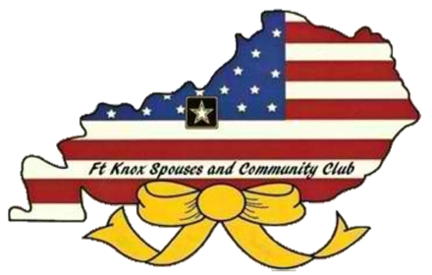
Fort Knox Spouses and Community Club
PO Box 177
Fort Knox, KY 40121
March 11, 2019

Dear Friends of Fort Knox,

The Fort Knox Spouses and Community Club (FKSCC), a non-profit organization, is reaching out to reputable vendors throughout our local community, the State of Kentucky, and surrounding States and asking them to participate in our 44rd Annual Fort Knox Holiday Bazaar. The Holiday Bazaar features handcrafted arts and crafts as well as collectibles, or like merchandise. We are happy to announce the dates for the 2019 Holiday Bazaar will be on Friday, November 1st, 11:00 a.m. – 6:00 p.m. and Saturday November 2nd, 10:00 a.m. – 4:00 p.m. The location is inside the historical Saber and Quill building at 118 Chaffee Avenue, Fort Knox, KY 40121.

The annual FKSCC Holiday Bazaar is a fundraising event that allows our club to support many different Solider and Family programs, military family member scholarships, and provide support to other worthy charities and organizations on Fort Knox and in the surrounding communities. Your participation in this year’s Holiday Bazaar will allow us to continue this fine tradition.

If you are interested in being a vendor at this year’s Holiday Bazaar, the booth fee is $115 for an approximately 10’X10’ booth space, or $90 for a 6’ table space. Your tables/display racks that you bring for your merchandise must fit within your booth space. Vendor Contracts received by September 6th will receive a $10 discount on their booth fee. The Saber and Quill will be open Thursday, October 31st, from 11:00 a.m. – 5:00 p.m. and Friday November 1st, at 8:00 a.m. for vendor set-up.

Please complete the enclosed Vendor Contract and Tax Agreement, include your booth fee, and mail to: FKSCC, ATTN: Holiday Bazaar, P.O. Box 177, Fort Knox, KY 40121 to reserve your booth. For more information or questions, please feel free to contact us through the FKSCC e-mail address, holidaybazaarfkscc@gmail.com.

Thank you so much for your generous support to the Fort Knox Spouses and Community Club. We sincerely hope you can participate in the 2019 Holiday Bazaar.

Sincerely,

Christine Simmons
FKSCC President
2018-2019

